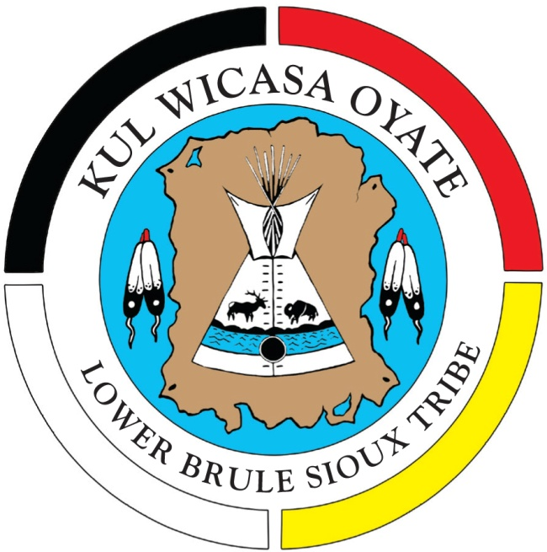

Lower Brule Envoirnmental Program
187 Oyate Circle
Lower Brule, SD 57548
605-473-0153
Website: lbst-epo.org

Unci Maka Hokici
“Voices for Mother Earth”

EPO Director – George Honeywell
Water Quality Coordinator - DJ Middletent
319 Coordinator -
Brownfields TRP Coordinator - Mary Jane Gourneau
Solid Waste Program – Director Tim Estes
Solid Waster Workers – Aaron Box

September 2019

The mission of EPA is to protect human health and to safeguard the natural environment --air, water and land--upon which life depends.
Since 1970, EPA has been working for a cleaner, healthier environment for the American people.
Brownfields Program description
EPA’s Brownfield’s Program is designed to empower states, communities, and other stakeholders in economic redevelopment to work together in a timely manner to prevent, assess, safely clean up, and sustainably reuse Brownfields.
Brownfields Program Tribal Vision
Contaminated or potentially contaminated sites located in Indian Country are restored to the highest and best use, based upon tribal priorities and available resources. The focus on brownfields revitalization helps instill the concept of environmental protection and reuse and leads to increased benefits in Indian Country.
Administer and implement the TRP Four Elements.
- Timely Survey & Inventory of Brownfield Sites.
- Oversight & Enforcement Authorities or Other mechanisms & Resources.
- Mechanism & Resources to Provide Meaningful Opportunities for Public Participation.
- Mechanisms for Approval of a Cleanup Plan & Verification & Certification that Clean-up are Complete and establishment of a Public Record.
- Develop and approve RFP’s.
- Manage/oversee contracts.
- Prepare Property Profile Forms.
- Obtain Training as needed and available.
- Inspect sites within the exterior boundaries of the Lower Brule Sioux Reservation.
- Resolve issues, concerns and complaints.
- Assists and provide technical assistance when necessary to EPA, Tribal Law Enforcement, Tribal Programs and the Tribal Council.
- Write quarterly, mid and end year reports due to EPA.
- Maintain Public Record for the Tribal Response Program.

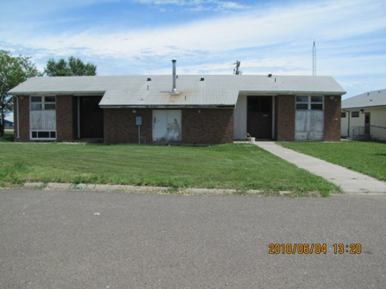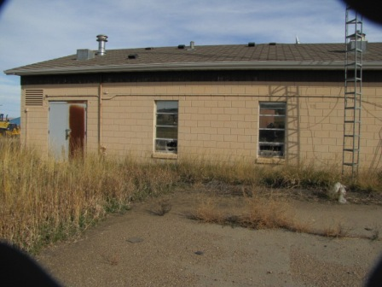
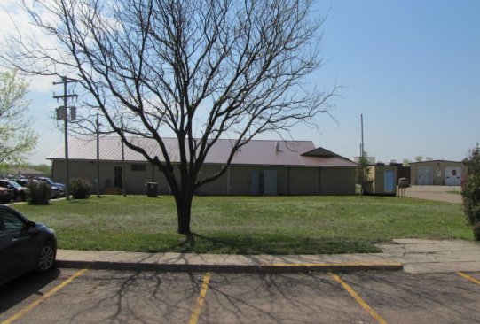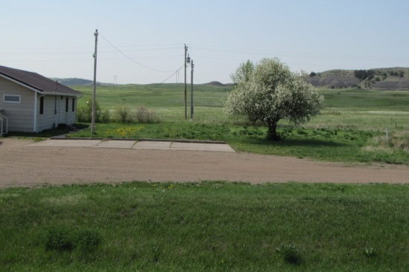
Old BIA Building Old BIA Jail
(Before & After) (Before & After)
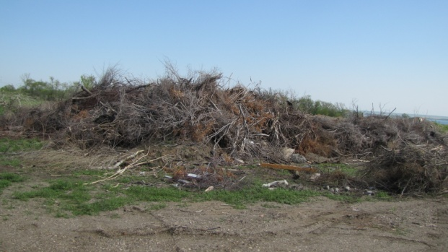
Rubble Site
Old Housing Authority Building 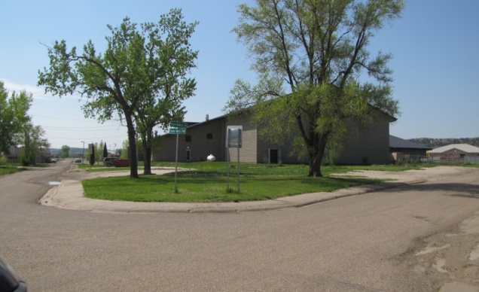
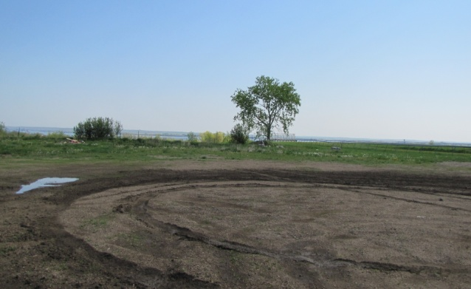
Old Rodeo Dump

Old West Brule Dump 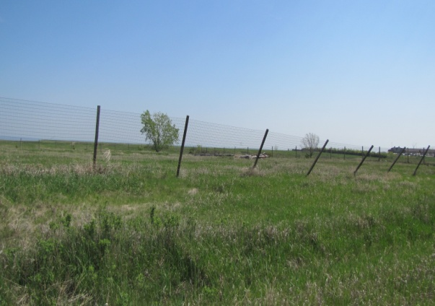
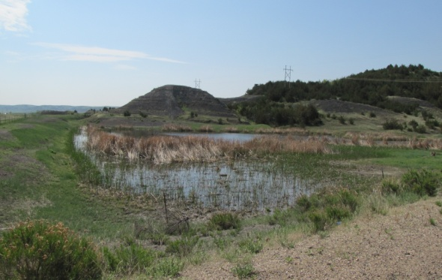
Kids Pond
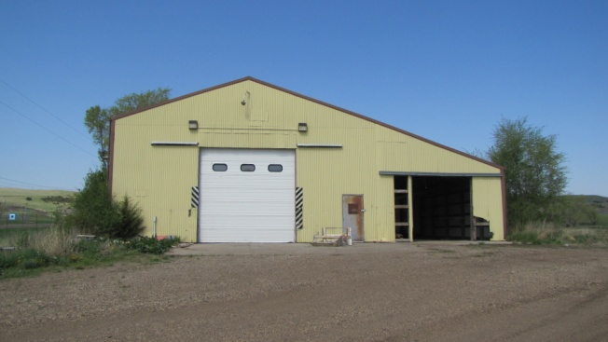
Old Transfer Station

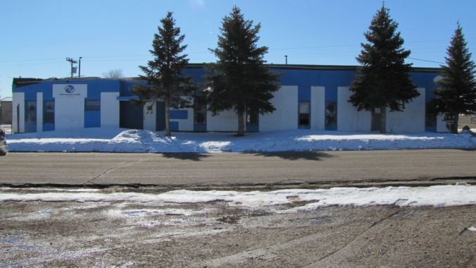
Old Boys & Girls Club
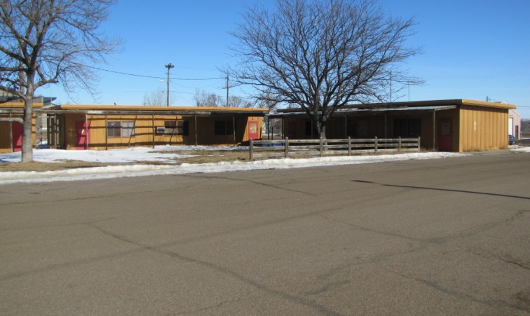
Old Yellow School Buildings

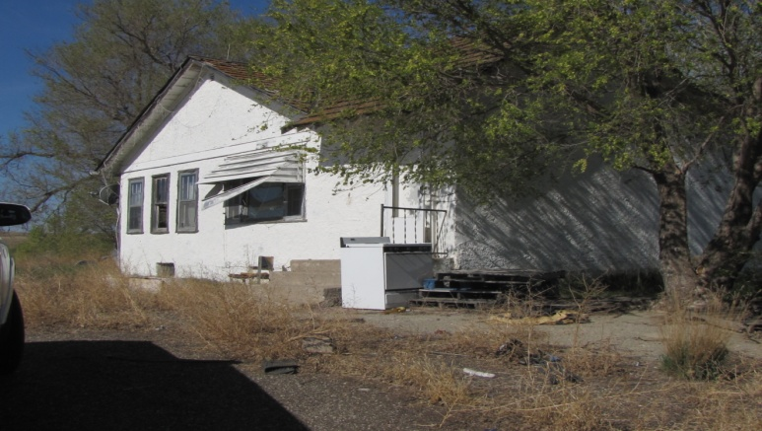
Old Durkin Curve Site

LBST TRP Brownfields Inventory List
- 2004-10 BIA Administration Building
- 2012-02 Old Housing Office
- 2011-01 Old BIA Jail
- Old Diabetic Building(Boxing Club) 1-26-13 Burned Down
- 2012-01 Old Transfer Station
- 2004-04 Old West Brule Dump
- Lagoon Rubble Site/ across form Red Store
- Sioux Boys-(Gas Tanks)
- 2004-03 Kids Pond
- 2000-01 Rodeo Dump
- Old Shooting Range
- Old Boys & Girls Club
- Old Yellow School Buildings

Rural Area
- 2004-02 Durkin Dump
- Durkin Curve House
- Thompson Site/Fort Hale Bottom

ATTENTION
The following is a list of what may be deposited at the Material Recovery Facility (MRF)
WOOD: Trees, Tree Limbs, Yard Waste, etc.
METALS: Iron, Steel, Rims, Bikes, Bed Frames, etc.
WHITE GOODS: etc. STOVES - REFRIGERATORS-
WATER HEATERS- FURNACES
OR leave all the big stuff by the curb of your home and the Solid Waste workers will pick it up! Please don’t leave it by the dumpsters or in the dumpsters.
Please throw your garbage in the dumpsters evenly.
THANK YOU FOR YOU COOPERATION!!!!!!
The Solid Waste Crew.

Environmental Health
Our cultural believes everything is connected. Example our health is connected to the health of the environment through the food we eat, the water we drink and the air we breathe. We need to create conditions in our Environment that are good for our health and the environment! We only have one earth!
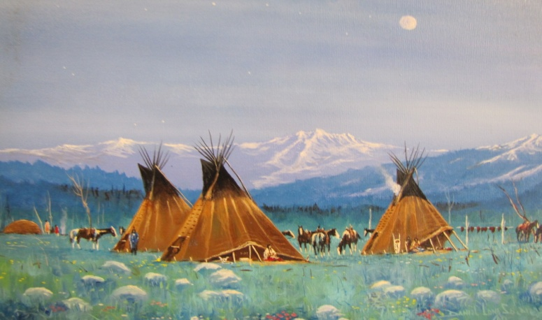

The Brownfields Grant/Workplan consists of 8 tasks.
Task 1 Timely survey and inventory if Brownfields sites on tribal land.
1.1 Tribal Land Survey
1.2 Maintain Brownfields Inventory
1.3 Prioritize Sites
Task 2 Oversight and enforcement authorities or other mechanisms and resources.
2. Oversight of all sites in the Public Record

Task 3 Mechanisms and resources to provide meaningful opportunities for public participation
3.1 Public Meetings
3.2 Dissemination of Information
3.3 LBST-EPO Website
Task 4 Mechanism for approval of a cleanup plan and verification and certification that cleanup is
complete
4.1 Mechanism for approval
Task 5 Public Record
5.1 Update Public Record
5.2 Public Record Accessible
Task 6. Program Enhancement
6.1 Trainings
6.2 Meetings
6.3 Professional Meetings
Task 7 Site-specific Assessment and Cleanup Activities
7.1 Phase II Assessment Work
7.2 Conduct Assessments
7.3 Cleanup of Sites
Three quarterly reports and one Final report are due during the Fiscal Year.
1. 1st Quarterly Report covers (October-November-December) Due January 31
2. 2nd Quarterly Report covers (January-February-March) Due April 29
3. 3rd Quarterly Report covers (April-May-June) Due July 29
4. 4th Quarterly/Final Report covers (July-August-September) Due October 31

Please everyone help keep our community clean!
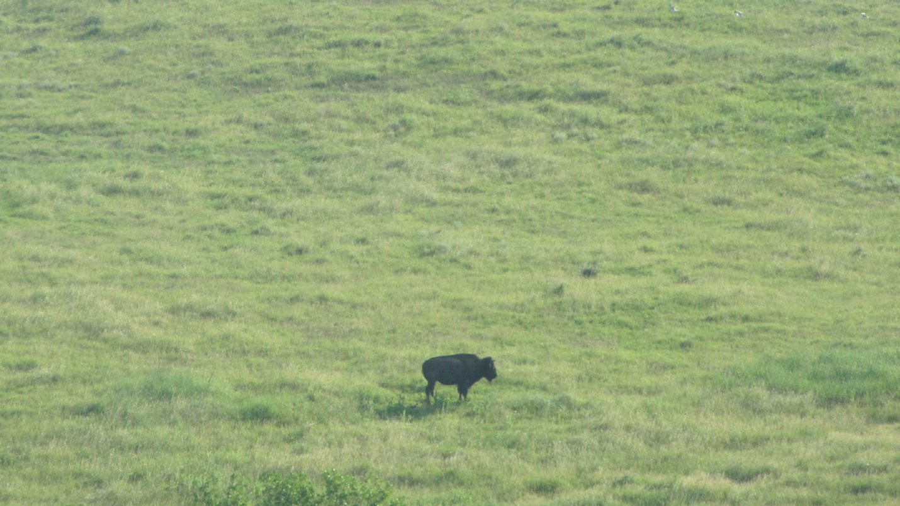

PUBLIC RECORD

PUBLIC RECORD
Lower Brule Sioux Tribe Brownfields/Tribal Response Program
(Updated 3-13-19)

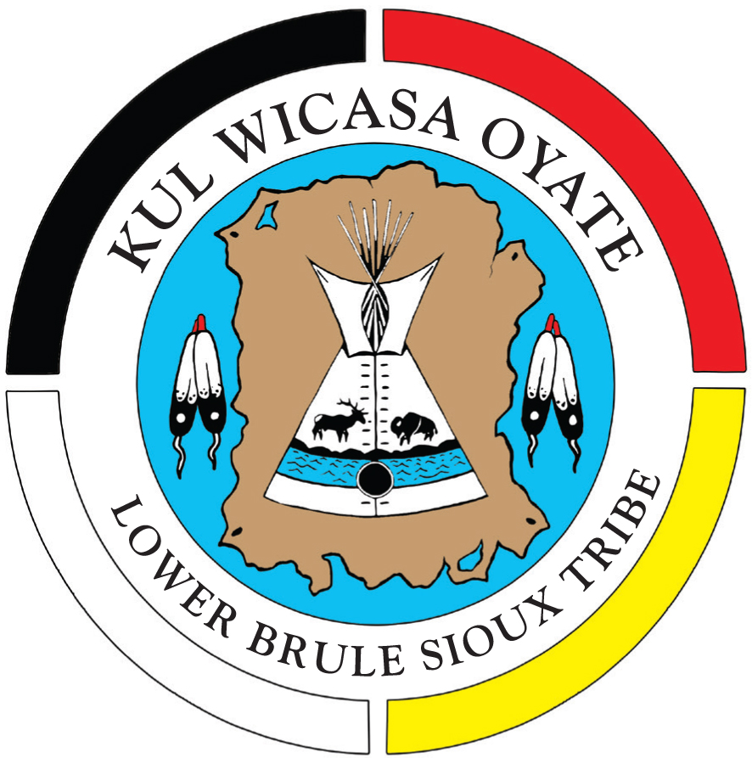

Rodeo Dump
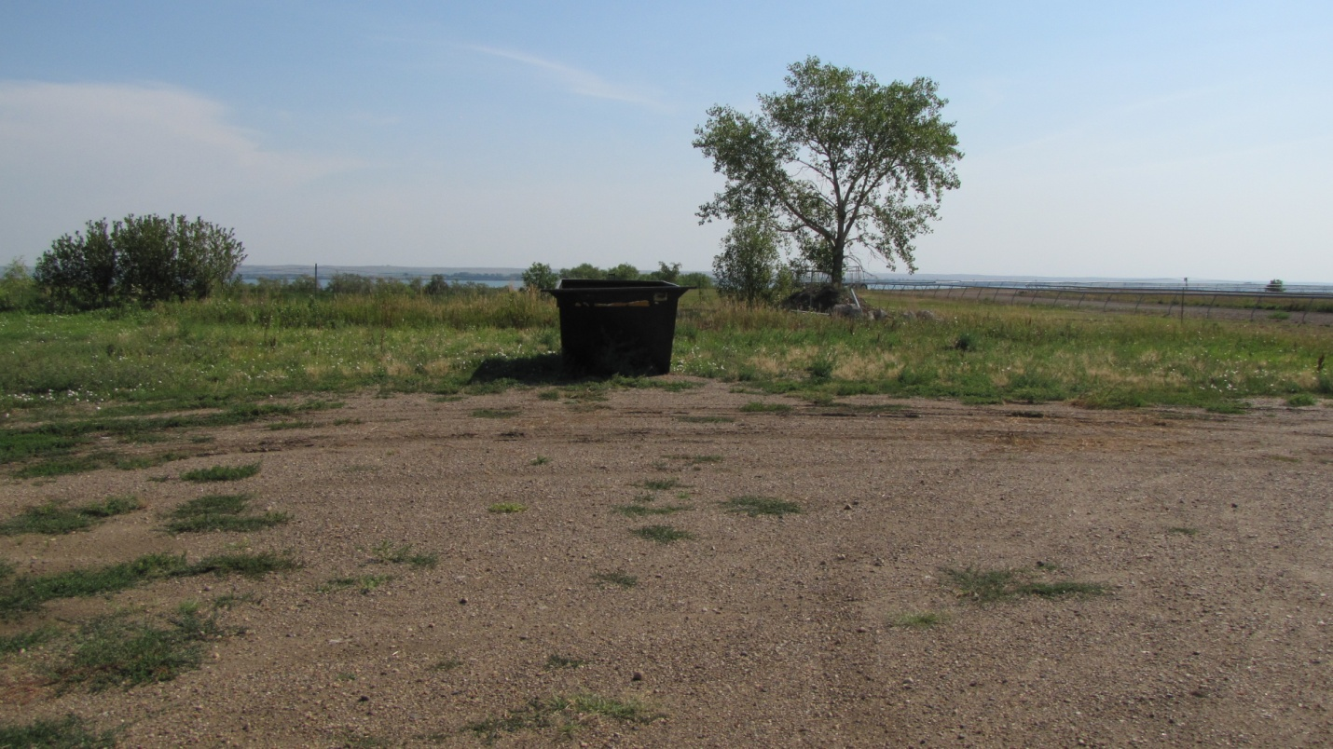
Site Name Rodeo Dump
Current Owner Lower Brule Sioux Tribe
Address Pow Wow Highway
Lat/Long 44 04’ 53 ‘N 99 35’ 03” W
Section 9 Township 107 N, Range 73W
Lyman County, SD

Date of: Phase I September 2004
Phase II September 2005
Phase III November 2006
Phase II July 2011
Suspected Contaminants SVOCs-Herbicides-Pesticides-Total Metals
Hydrocarbons
Institutional Controls None
Site acreage 1.00
Type of Site Old Dump Site
Date Action is Planned Site cleaned up

Kids Pond
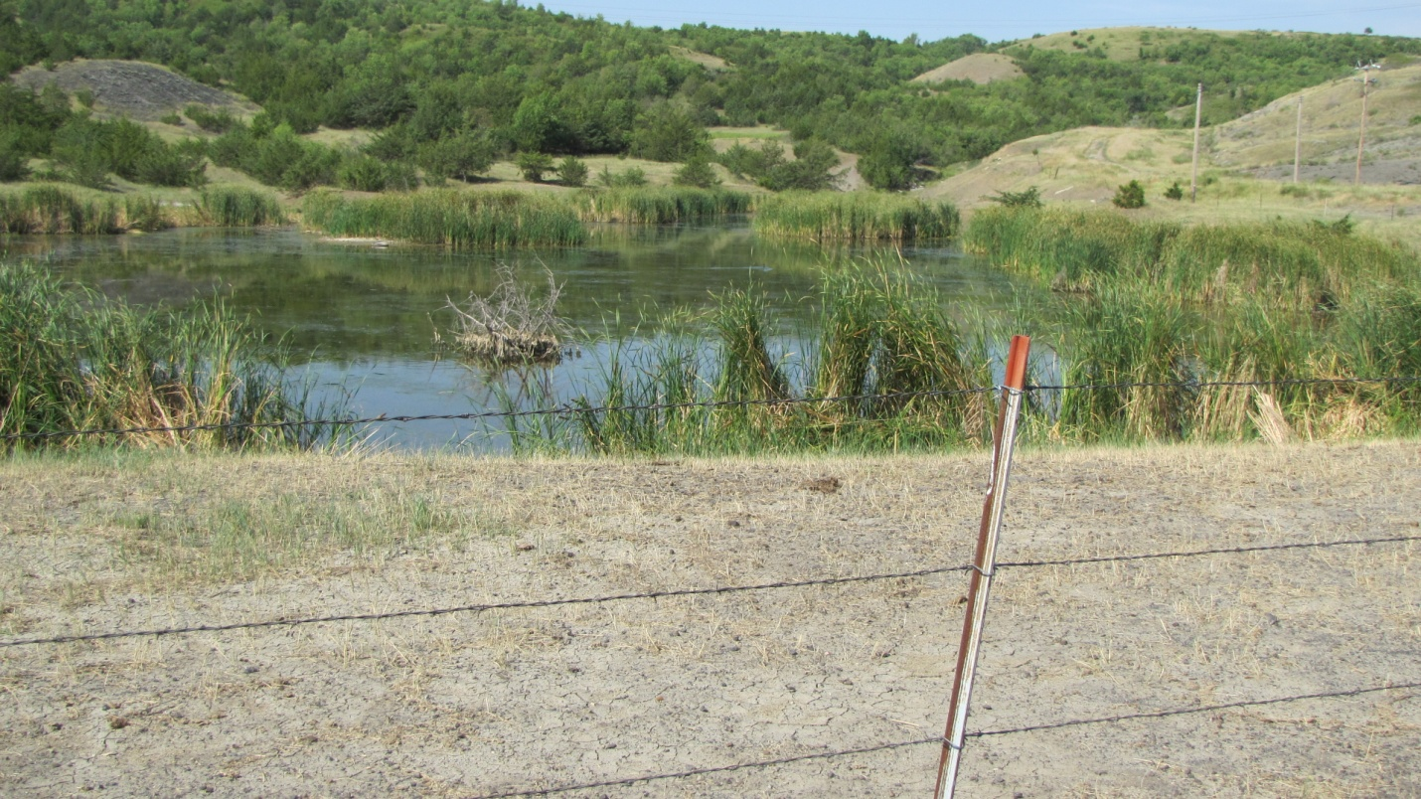

Site Name Kids Pond
Current Owner Lower Brule Sioux Tribe
Address BIA Rt 10 Lower Brule, SD 57548
Lat/Long 44 04’ 18” N 99 35’ 50” W
Section 26 Township 109 N, Range 76W
Lyman County, SD

Date of: Phase I September 2004
Phase II September 2005
Phase III November 2006
Phase II July 2011
Suspected Contaminants VOCs- Chlorinated Herbicides

Institutional Controls Pond is fenced
Site acreage 1.65
Type of Site Old Dump Site
Date Action is Planned Site cleaned up
Old West Brule Dump
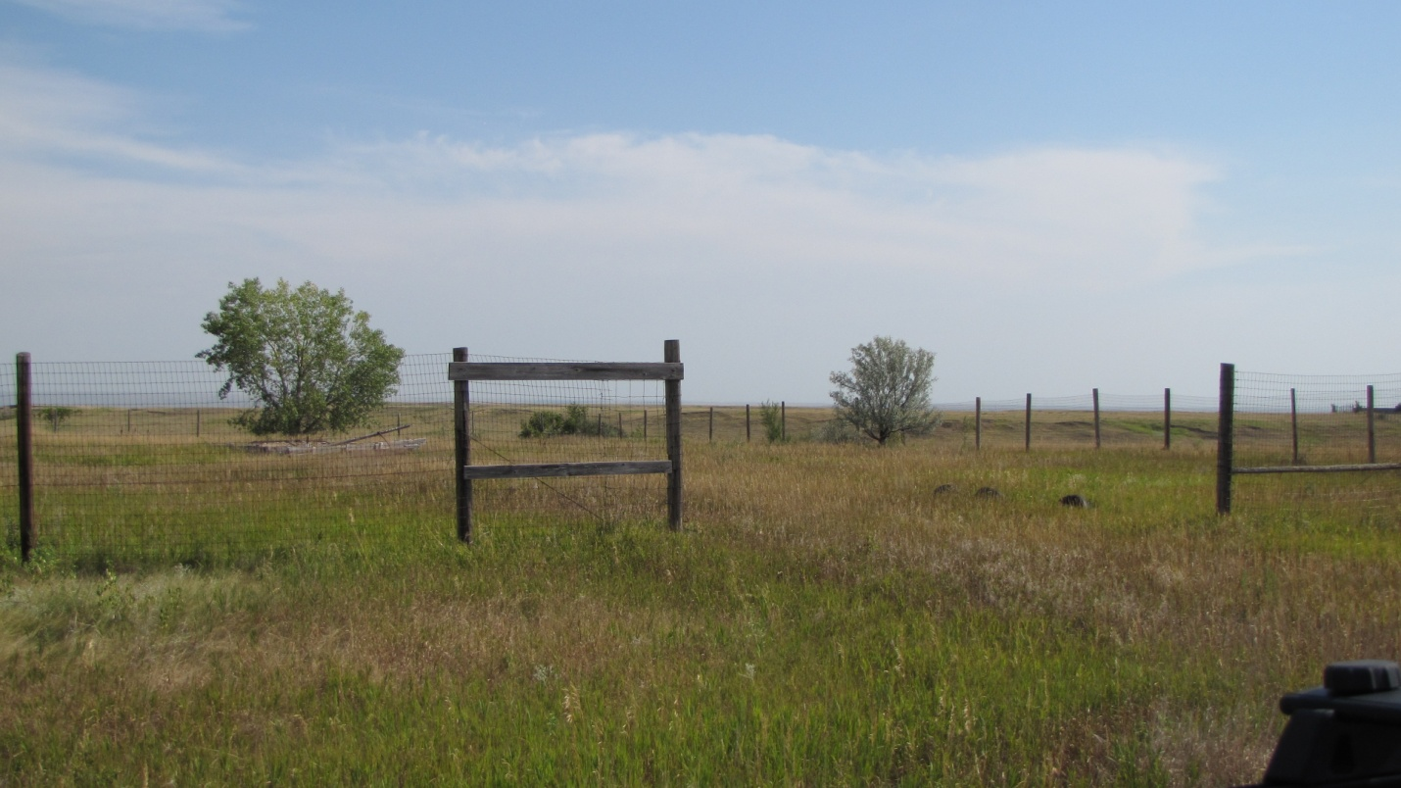
Site Name Old West Brule Dump
Current Owner Lower Brule Sioux Tribe
Address BIA Route 10 Lower Brule, SD 57548
Lat/Long 44.07836 N 99.61294W
T531-2 Lyman County, SD
Date of: Closed 1996
Capped 2003
Phase I May 2003
Phase II Dec 2003
Limited Phase I/Transaction Screen 2013

Suspected Contaminants Low levels- VOCs, SVOC’s, (soil only)
Institutional Controls Site is fenced
Site acreage 10
Type of Site Old Dump Site
Date Action is Planned No further action planned at this time

Old BIA Jail
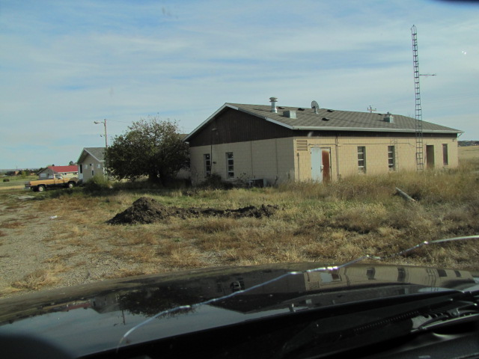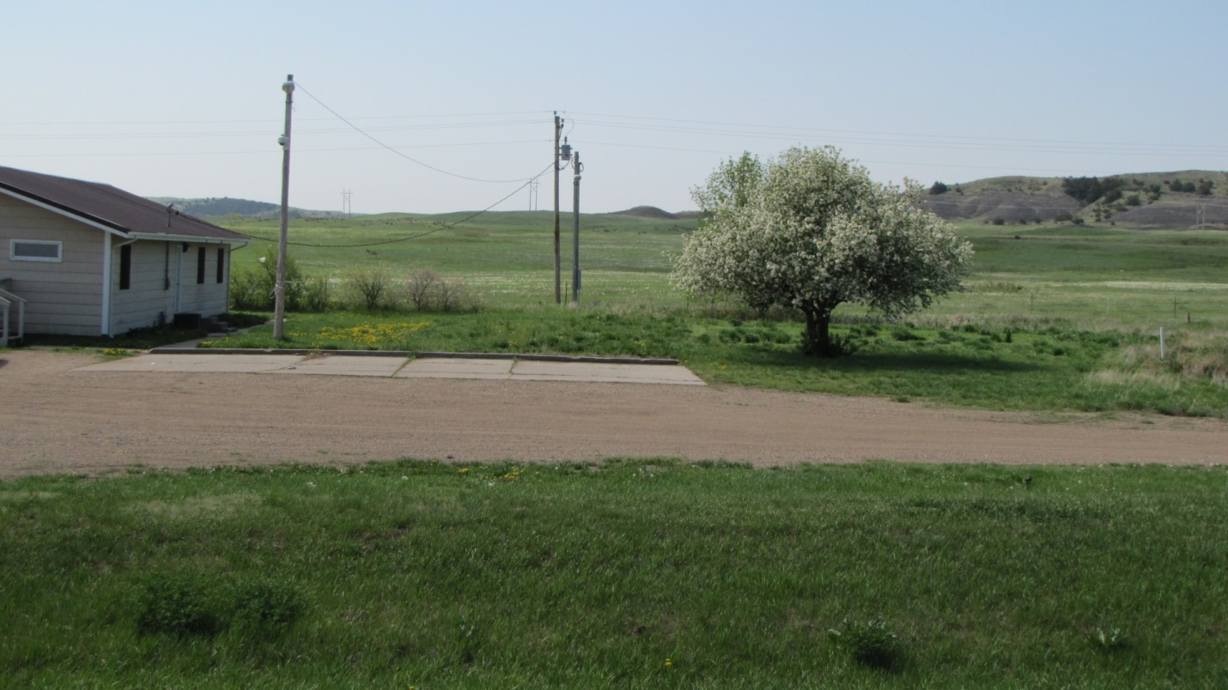

Site Name Old BIA Jail
Current Owner Lower Brule Sioux Tribe
Address BIA Route 10 Lower Brule, SD 57548
Lat/Long 44.067900-44 “4’4.4 N 99.578900-99”34’44.0
Land Description T4079-F Lot 5B WSec. 14, T107N R73W, Lyman County

Date of: Phase I October 2003

Suspected Contaminants Asbestos-Lead based paint
Institutional Controls None
Site acreage 1.1
Type of Site Old Building Site
Date Action is Planned This building was demolished by the LBST and site was
cleaned up

Old BIA Administration Building
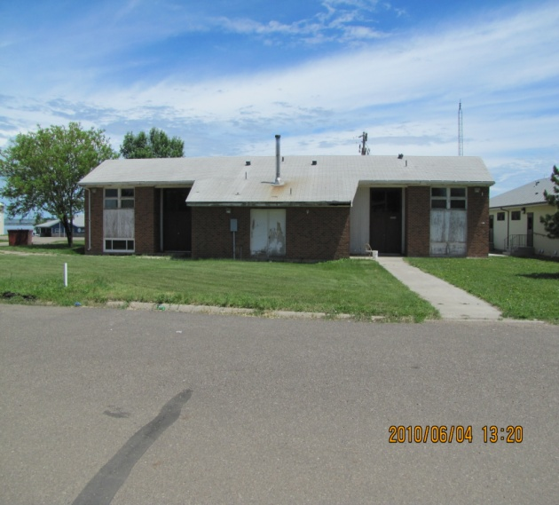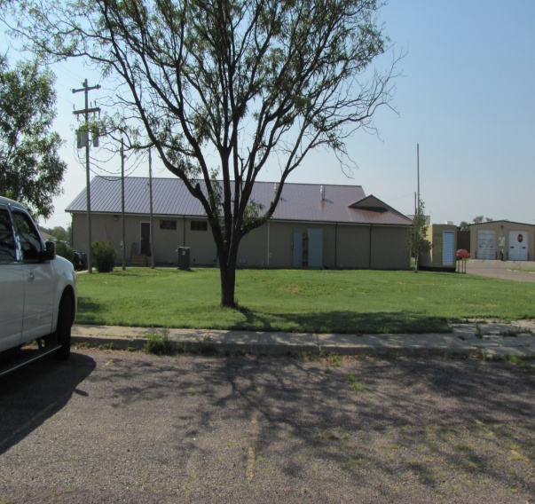
Site Name Old BIA Administration Building
Current Owner Lower Brule Sioux Tribe
Address 90001 Red Cloud Street, Lower Brule, SD 57548
Lat/Long 44 04’ 53 ‘N 9 35’ 03” W
Land Description Section 9. Township 107 N, Range 73W
Lyman County, SD

Date of: Phase I September 2004
Phase II September 2005
Phase III November 2006
Phase II July 2011
Suspected Contaminants SVOCs-Herbicides-Pesticides-Total Metals
Hydrocarbons
Institutional Controls None
Site acreage 1.00
Type of Site Old Dump Site
Date Action is Planned This building was demolished by the LBST and site was
cleaned up

Old Transfer Station
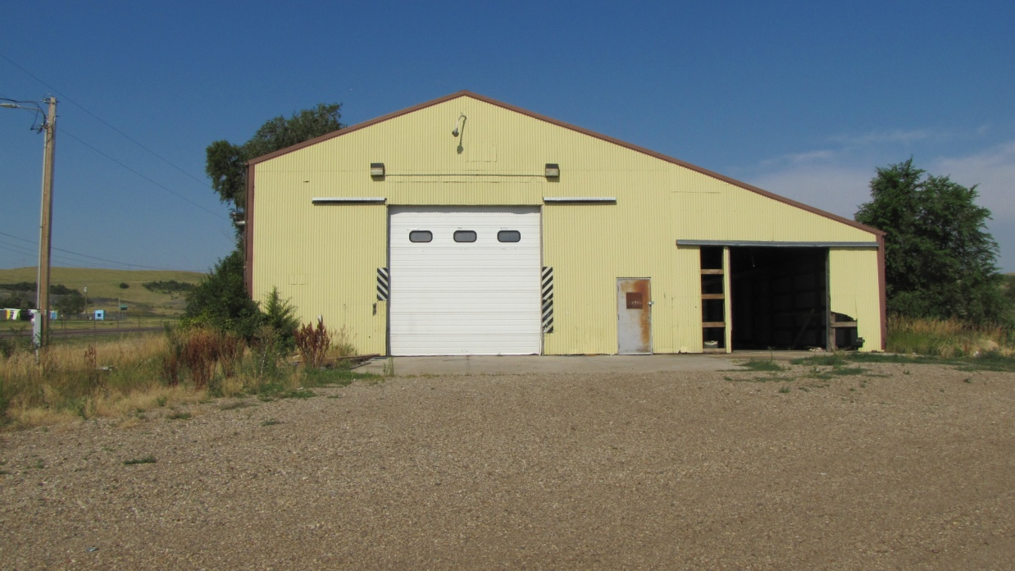

Site Name Old Transfer Station
Current Owner Lower Brule Sioux Tribe
Address Pow Wow Highway Lower Brule, SD 57548
Lat/Long 44. 4’2” N 99.31’52”
Land Description T4079-F Lot 5B WSec. 14, T107N R73W, Lyman County

Date of: Limited Phase I/TS August 2012
Suspected Contaminants
Institutional Controls This building is being used by the Lower Brule
Construction Company to store building materials
Site acreage 2.5
Type of Site Old Transfer Station for Solid Waste Program
Date Action is Planned None

Former Housing Authority Building
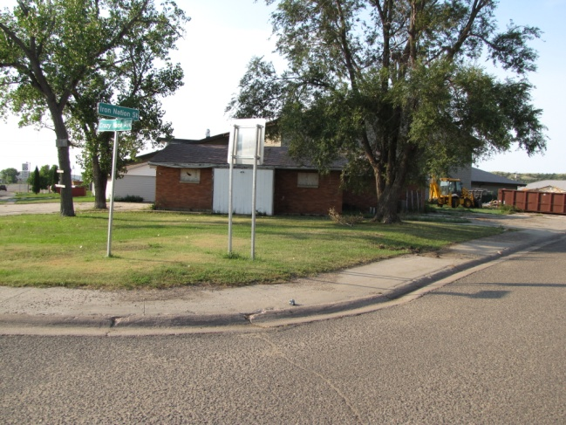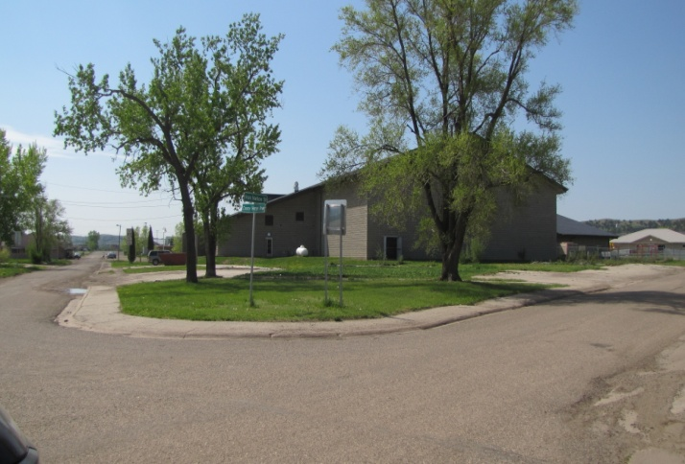
Site Name Former Housing Authority Building
Current Owner Lower Brule Sioux Tribe
Address 633 Crazy Horse Street, Lower Brule, SD 57548
Lat/Long 44. 4’24” N 99.34’42”W
Land Description T4079-F Tract #343-T-343030/T4030-A/T4079-F

Date of: Limited Phase I/TS September 2012
Phase II August 2012
Submitted Cleanup Grant December 2014
Grant Approved May 2015
Cleanup Grant Competed September 2017

Suspected Contaminants Asbestos-Lead-Polychlorinated Biphenyls
Institutional Controls None
Site acreage 0.625
Type of Site Building Site
Date Action is Planned Site cleaned up with Cleanup Grant

Old Diabetic Building
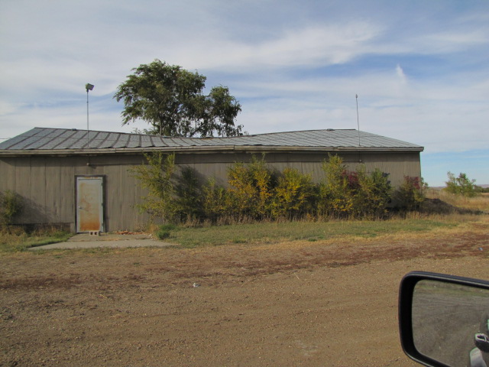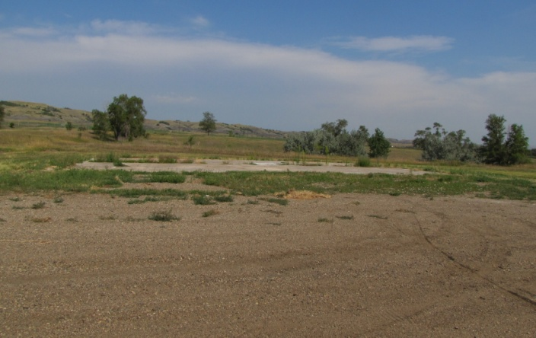

Site Name Old Diabetic Building
Current Owner Lower Brule Sioux Tribe
Address 705 Pow Wow Highway
Lat/Long 44. 4’45.2” N 99.35’14.9”
Land Description T781, NW1/4SW1/4SE1/4SE1/4SE1/1 Sec. 9
T7N,R73W,5Pm

Date of:
Limited Phase I/TS April 2013
Suspected Contaminants
Institutional Controls This building burned down 1-26-13. The tribe
cleaned up the site.
Site acreage 0.625
Type of Site Building Site
Date Action is Planned None

Old Durkin Cure Site
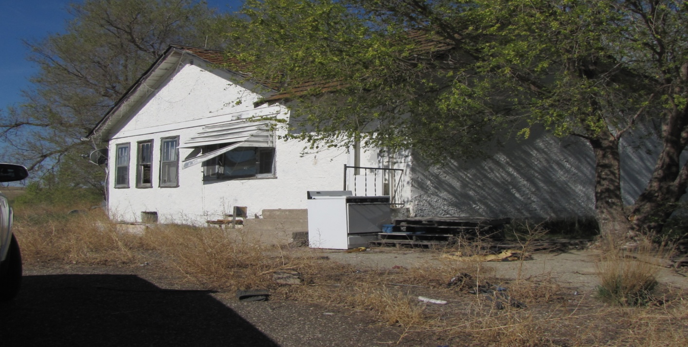
Site Name Old Durkin Curve Site
Current Owner Lower Brule Sioux Tribe
Address 31138 Highway 1806, Lower Brule, SD 57548
Lat/Long 44. 13’20” N 99.55’49”W
Land Description T109N,R76W. 5PM Stanley County

Date of:
Limited Phase I/TS August 2014
Phase II July 2015
Suspected Contaminants ACM, LBP, Lead, Mercury, Mold, Elevated Metals
Institutional Controls Fenced
Site acreage 10
Type of Site Building Site
Date Action is Planned

Sioux Boys Gas Station
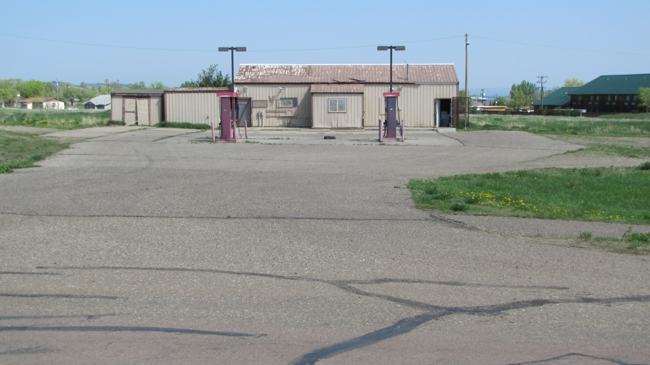

Site Name Sioux Boys Gas Station
Current Owner Stacie Her Many Horses
Address 32908 Iron Nation Road
Lat/Long 44. 069204 99.579083
Land Description

Date of:
Limited Phase I/TS May 2015
Suspected Contaminants Watching the Gas Tanks
Institutional Controls None
Site acreage
Type of Site Gas Tanks
Date Action is Planned None

Thompson Site Fort Hale Bottom
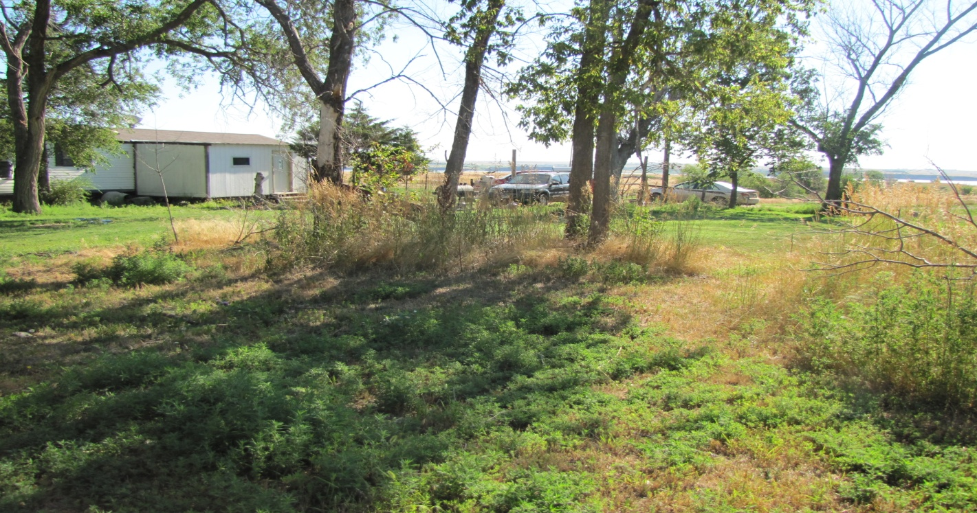
Site Name Thompson Site Fort Hale Bottom
Current Owner Sheldon Fletcher
Address 23561 Fort Hale Bottom Road Reliance SD 57569
Lat/Long
Land Description

Date of:
Limited Phase I/TS February 2016
Suspected Contaminants zinc phosphide
Institutional Controls None
Site acreage
Type of Site
Date Action is Planned None

Old Boys & Girls Club
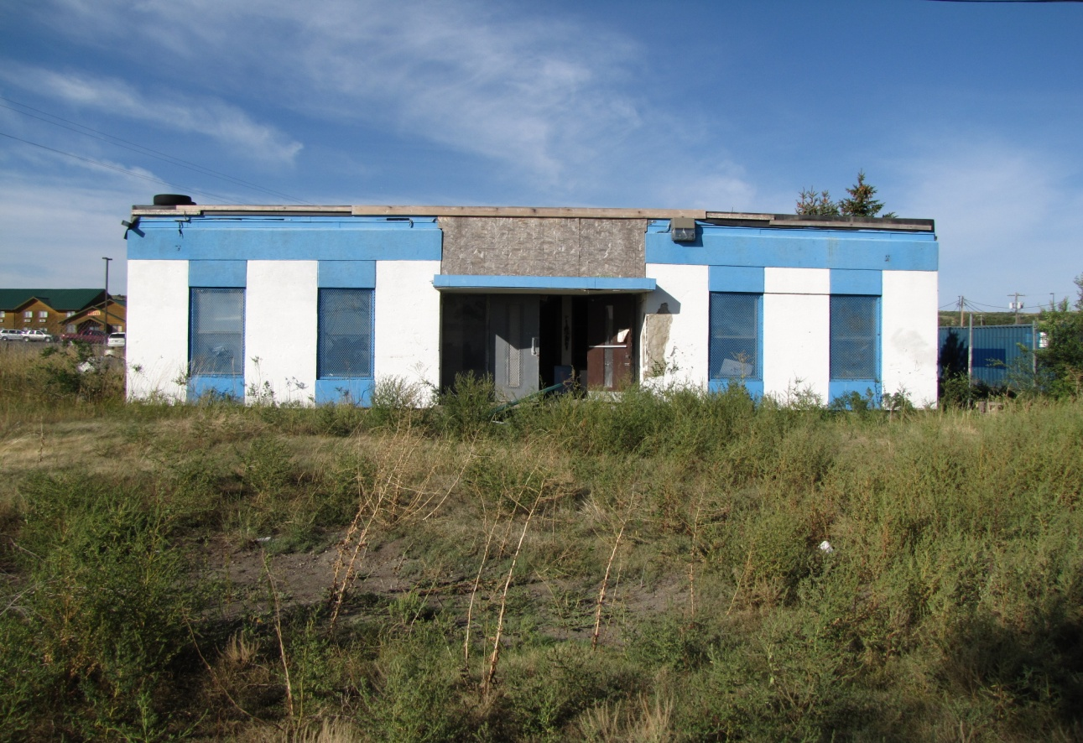

Site Name Old Boys & Girls Club
Current Owner Lower Brule Sioux Tribe
Address 131 Sitting Bull Street, Lower Brule, SD 57548
Lat/Long 44.071914N 99.577600W
Land Description 343 T4030

Date of:
Limited Phase I/TS May 2017
Phase II October 2017

Suspected Contaminants asbestos
Institutional Controls None
Site acreage 0.2
Type of Site Building
Date Action is Planned None

Old Yellow School Buildings
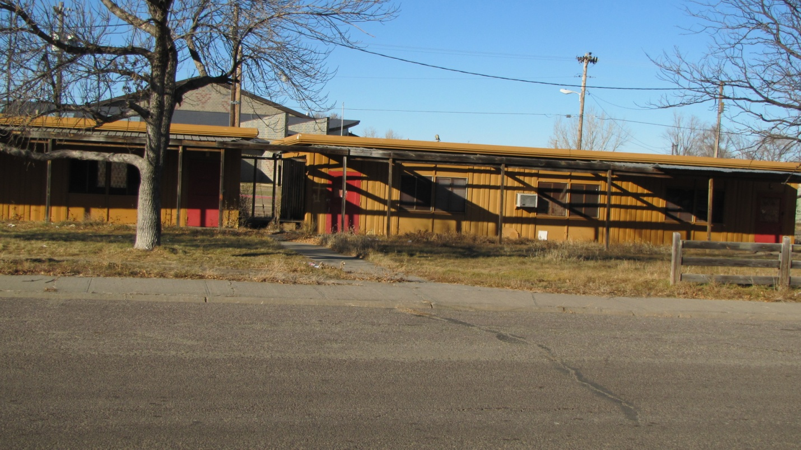

Site Name Old Yellow School Buildings
Current Owner Lower Brule Sioux Tribe
Address 212 Sitting Bull Street, Lower Brule, SD 57548
Lat/Long 44.072040N 99.578727W
Land Description T107N, R73W

Date of:
Limited Phase I/TS June 2017
Phase II October 2017

Suspected Contaminants asbestos, Lead, Mercury, PCBs
Institutional Controls None
Site acreage 0.2
Type of Site Building
Date Action is Planned None

Old Shooting Range
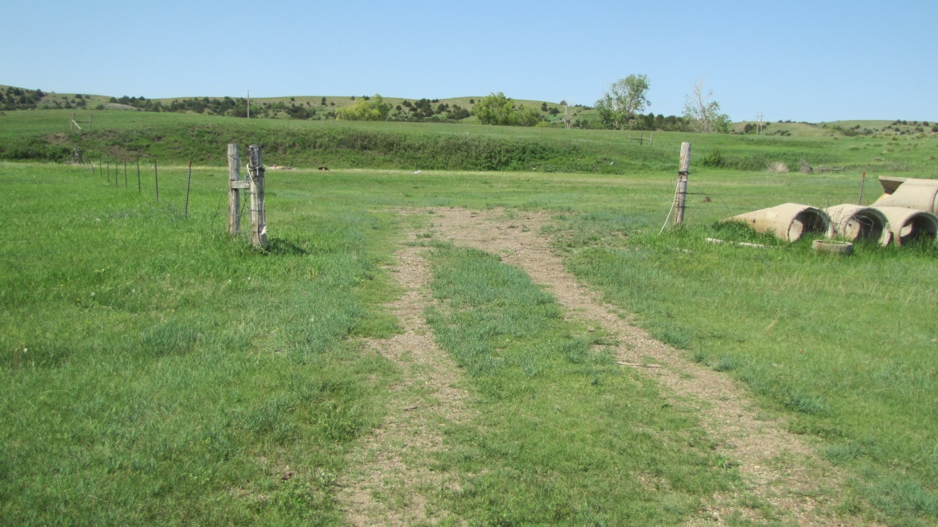

Site Name Old Shooting Range
Current Owner Lower Brule Sioux Tribe
Address BIA 5, Lower Brule, SD 57548
Lat/Long 44. 4’11”N 99.34’42”W
Land Description T107N, R73W

Date of:
Limited Phase I/TS April 2018

Suspected Contaminants Lead
Institutional Controls None
Site acreage 2.5
Type of Site Shooting Range
Date Action is Planned None

Old Durkin Dump

Site Name Old Durkin Dump
Current Owner Lower Brule Sioux Tribe
Address Hwy 1806, Lower Brule, SD 57548
Lat/Long 44. 13’20”N 99.56’31”W
Land Description Section 26 T109N R76W Stanley County

Date of:
Phase I September 2004
Phase II September 2005
Phase III November 2006
Phase II July 2011

Suspected Contaminants
Institutional Controls None
Site acreage 0.85
Type of Site Old Ranch Dump
Date Action is Planned None

Lower Brule Sioux Tribe
Environmental Protection Office
Brownfields Tribal response Program
187 Oyate Circle
Lower Brule, South Dakota 57548
Phone: 1-605-473-0163

September, 2019

It’s been a beautiful spring and summer! A spring and summer to remember. Lots of rainy

weather! Lots of flooding. Really not much of a summer but I have never seen it this green in

September! It’s now the time of the year to check your furnace and make sure it is ready for

winter. Time to clean your garden and flower beds. Put all you summer stuff away. Man time

flies.

Thank you everyone that got out and helped with the Community Cleanup. A big thank you to

the Golden Buffalo for supplying the garbage bags this year.

We are now on our last quarter of this fiscal year 2019.

Checked all my sites. This has to been done on quarterly bases. No new dumping occurring.

Thank You! It’s up to us to keep our homeland litter free.

Our office is always looking for new sites. If you know of any please let me know.

If you want to know anything about the Brownfields Program or need information about

anything such as mold, asbestos, lead or the environmental. The Brownfields Program has a lot

of good stuff posted on our website or stop in and see me at the EPO Office. I would love to visit

with you and show you what we do. Please check out our website lbst-epo.org.

Thank you all for your support of our program.

Brownfields Coordinator Mary Jane Gourneau

Did You Know!
1. America’s solid waste industry collected and processed more than 61.3 million
tons of recyclables in 2009 and more than 20.8 million tons of yard and food
waste.
2. The 63.6 billion cans recycled in 2009 alone would make 171 circles around the
earth.
3. Glass can be recycled and indefinite number of times and never wears out.
4. Every ton of paper recycled saves more than 3.3 cubic yards of landfill space.
5. If we recycled all the newspapers printed on the U.S. on a typical Sunday, we
would save 550,000 trees or about 26 million trees per year.
6. An average kitchen-size bag of trash contains enough energy to light a 100 watt
light bulb for more than 24 hours.
7. The average American discards 4.34 pounds of garbage every day.
8. It is the little things citizens do that will make the difference.
9. Old paper can be used to make new insulation, paper towels, tissues, book
covers, puzzles, packaging, greeting cards and newsprint.
10. Old aluminum cans become new aluminum cans and siding.
11. Old steel cans are recycled into new appliances and auto parts.
12. Old corrugated boxes can become new cereal boxes and egg cartons.
13. Old plastic bottles can become new carpeting, plastic lumber, toys and fleece
clothing.
14. Old tires can be shredded and used for new road paving and playground
surfaces.
15. Old glass containers can be used to make new decorative tile and paving
material.
It will take this long to decompose:
Aluminum Cans: 550 years (but if recycled it can be used within 6 weeks)
Paper: 2-3 weeks
Cardboard: 4-6 weeks
Plastic bags: 500 years
Plastic beverage bottles: 450 years
Disposable diapers: 500-600 years
Cigarette Butts: 100 years

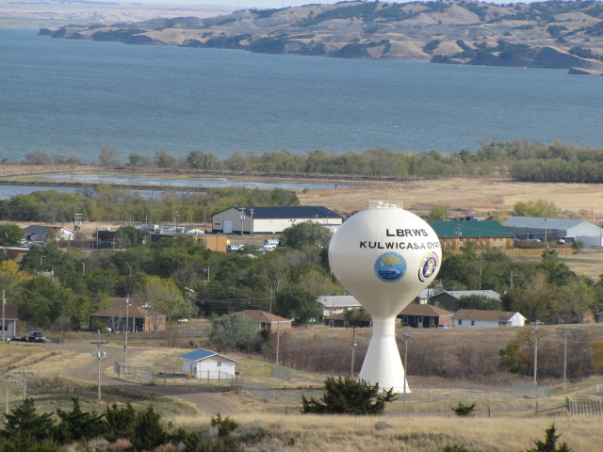

Thank you for all your support for our Lower Brule Environmental
Office.
www.lbst-epo.org
605-473-0163

